Postoperative Complications and Associated Outcomes Following Intestinal Stoma Formation: A Systematic Review and Exploratory Meta-Analysis
Running title: Intestinal Stoma Outcomes
Manuscript type: Systematic Review and Meta-Analysis
Abstract
Objective: To synthesise evidence on postoperative complications, associated risk factors, and quality of life among patients with intestinal stomas and to provide an exploratory meta-analysis of standardised study-level effects.
Material and Methods: PubMed/MEDLINE, Scopus, and Web of Science were searched for peer-reviewed quantitative studies published from 2017 onward. Study selection followed the Preferred Reporting Items for Systematic Reviews and Meta-Analyses (PRISMA) 2020 statement. Eligible studies involved patients with intestinal stomas and reported postoperative or stoma-related complications, risk factors, quality-of-life outcomes, or effect estimates suitable for quantitative synthesis. For the exploratory meta-analysis, study-level effects were analysed on a common standardised effect scale.
Results: Of 295 records identified, 5 duplicates were removed, 290 records were screened, and 70 full-text articles were assessed. Twelve studies were included in the systematic review, of which 11 contributed to the quantitative meta-analysis; one quality-of-life study was synthesised narratively. The exploratory meta-analysis yielded a pooled standardised effect estimate of 1.12 (95% confidence interval [CI] 0.60–1.65; t(10)=4.80, p<0.001). Between-study heterogeneity was substantial (Q(10)=104.53, p<0.001; I²=86.98%), and the funnel plot was not fully symmetrical, warranting cautious interpretation of the pooled estimate.
Conclusion: Intestinal stoma outcomes vary according to patient characteristics, stoma type, clinical phase, and outcome definition. The exploratory quantitative synthesis yielded a pooled standardised effect estimate; however, substantial heterogeneity limits interpretation of this summary as a single clinical measure of risk. The pooled estimate should therefore be considered alongside outcome-specific findings and patient-centred quality-of-life outcomes.
Keywords: intestinal stoma; ileostomy; colostomy; postoperative complications; risk factors; quality of life
Introduction
Intestinal stoma formation creates a connection between the intestinal lumen and the abdominal wall to divert fecal or intestinal contents, either temporarily or permanently. It is used in colorectal cancer, inflammatory bowel disease, abdominal trauma, obstruction, perforation, anal sphincter dysfunction, and other conditions requiring intestinal diversion. Although stoma formation may be life-saving, postoperative morbidity remains substantial. Reported complication rates vary widely and include skin irritation, infection, necrosis, stenosis, prolapse, retraction, parastomal hernia, and nutritional disturbances associated with high-output stoma.^{1,2}
Complications may occur from the early postoperative period through long-term stoma care and subsequent closure. Preoperative stoma-site marking has been associated with fewer stoma and peristomal complications, including in emergency surgery.^{3,4} Risk is also influenced by patient characteristics, stoma type and location, abdominal-wall anatomy, treatment exposure, and postoperative clinical conditions.^{5–8}
Peristomal skin disorders are particularly important because leakage, pain, odor, embarrassment, and impaired appliance adhesion can directly affect daily functioning. Evidence has linked loop stoma, low stoma height, chemotherapy, and diabetes mellitus with peristomal skin disorders or worsening skin conditions.^{9–11} Late complications, including parastomal hernia and morbidity around stoma closure, also affect clinical outcomes and health-related quality of life.^{12–14}
Quality of life is a patient-centred outcome because living with a stoma may alter body image, dietary habits, sleep, work, social participation, sexual relationships, and perceived safety during routine activities. Reported determinants include stoma type, age, permanence of the stoma, perceived stress, physical symptoms, and social or functional conditions.^{15–18}
Existing syntheses have generally focused on individual preventive factors, specific complications, or quality-of-life outcomes rather than the broader continuum of postoperative morbidity.^{3,6,19,20} The present systematic review and exploratory meta-analysis therefore aimed to synthesise evidence on postoperative complications, associated risk factors, and quality of life among patients with intestinal stomas, while using a standardised quantitative synthesis to summarise study-level effects across clinically heterogeneous outcomes.
Material and Methods
Study design and reporting
This systematic review and meta-analysis followed the Preferred Reporting Items for Systematic Reviews and Meta-Analyses (PRISMA) 2020 statement for identification, screening, eligibility assessment, and inclusion of studies.²¹ The review protocol was not registered in PROSPERO. The exploratory standardised quantitative synthesis followed general principles of clinical meta-analysis described in the Cochrane Handbook.²²
Review question and eligibility criteria
The review question was structured using the Population, Intervention/Exposure, Comparison, and Outcome (PICO) framework. Patients with intestinal stomas were the population; clinical, technical, or treatment-related factors were the exposures; patients without the relevant risk factor or reference groups were comparators; and postoperative complications or quality-of-life outcomes were the outcomes of interest. Eligible designs included prospective cohort, retrospective cohort, case-control, analytical cross-sectional, registry-based, and observational comparative studies. Reviews, systematic reviews, scoping reviews, meta-analyses, narrative reviews, editorials, letters, protocols, case reports, and case series were excluded from the primary quantitative synthesis. The review framework is presented in Table 1.
Table 1. PICO framework of the review
Component | Information
P (Population) | Patients with intestinal stoma, including ileostomy, colostomy, jejunostomy, enterostomy, loop stoma, end stoma, temporary stoma, or permanent stoma.
I (Exposure) | Clinical, technical, and treatment-related factors, including stoma type, emergency/elective surgery, stoma-site marking, diabetes mellitus, obesity, American Society of Anesthesiologists (ASA) score, chemotherapy, radiotherapy, loop/end stoma, and stoma height.
C (Comparison) | Patients without the relevant risk factor, reference groups, comparison stoma types, patients without complications, or patients with better quality-of-life outcomes.
O (Outcome) | Postoperative and stoma-related complications, peristomal skin complications, mucocutaneous separation, necrosis, retraction, prolapse, parastomal hernia, high-output stoma, stoma outlet obstruction, readmission, surgical-site infection, stoma closure/reversal complications, and quality of life.
Information sources and search strategy
PubMed/MEDLINE, Scopus, and Web of Science were searched for peer-reviewed articles published from 2017 onward in English and/or Indonesian. Search terms combined concepts for intestinal stoma and related procedures with postoperative or stoma-related complications, risk factors, predictors, odds ratios, confidence intervals, and quality of life using Boolean operators. The database-specific search strategies and records identified are presented in Table 2.
Table 2. Database search strategies and records identified
Database | Search strategy | Records
PubMed/MEDLINE | ("intestinal stoma" OR ostomy OR stoma OR ileostomy OR colostomy OR enterostomy) AND ("postoperative complications" OR "stoma-related complications" OR "peristomal skin complications" OR "mucocutaneous separation" OR "parastomal hernia" OR "high-output stoma" OR readmission OR "surgical site infection") AND ("risk factors" OR predictor OR determinants OR "odds ratio" OR "confidence interval" OR "quality of life" OR HRQoL OR "Stoma-QOL") | 92
Scopus | TITLE-ABS-KEY ("intestinal stoma" OR ostomy OR ileostomy OR colostomy OR enterostomy) AND TITLE-ABS-KEY ("postoperative complication" OR "stoma-related complication" OR "peristomal skin complication" OR "parastomal hernia" OR "high-output stoma" OR retraction OR prolapse OR necrosis OR readmission) AND TITLE-ABS-KEY ("risk factor" OR predictor OR determinant OR "quality of life" OR HRQoL OR "odds ratio" OR "confidence interval") AND PUBYEAR > 2016 | 118
Web of Science | TS=("intestinal stoma" OR ostomy OR ileostomy OR colostomy OR enterostomy) AND TS=("postoperative complication" OR "stoma-related complication" OR "peristomal skin complication" OR "mucocutaneous separation" OR "parastomal hernia" OR "high-output stoma" OR readmission OR "surgical site infection") AND TS=("risk factor" OR predictor OR determinant OR "quality of life" OR HRQoL OR "Stoma-QOL") | 85
Total | — | 295

Study selection
The initial search yielded 295 records: 92 from PubMed/MEDLINE, 118 from Scopus, and 85 from Web of Science. After removal of 5 duplicate records, 290 records underwent title and abstract screening. During screening, 220 records were excluded. Seventy articles proceeded to full-text assessment. At the full-text stage, 58 articles were excluded: 18 did not report extractable odds ratios, p-values, and confidence intervals; 10 did not have a population specific to patients with intestinal stoma; 9 did not report analyzable risk factors; 7 did not clearly report complication or quality-of-life outcomes; 8 had inappropriate study designs; and 6 did not provide full-text access. Twelve studies were included in the systematic review. Eleven studies contributed to the quantitative meta-analysis, while the quality-of-life study was retained for narrative synthesis. The study-selection process is shown in Figure 1.
Figure 1. PRISMA 2020 flow diagram of study selection
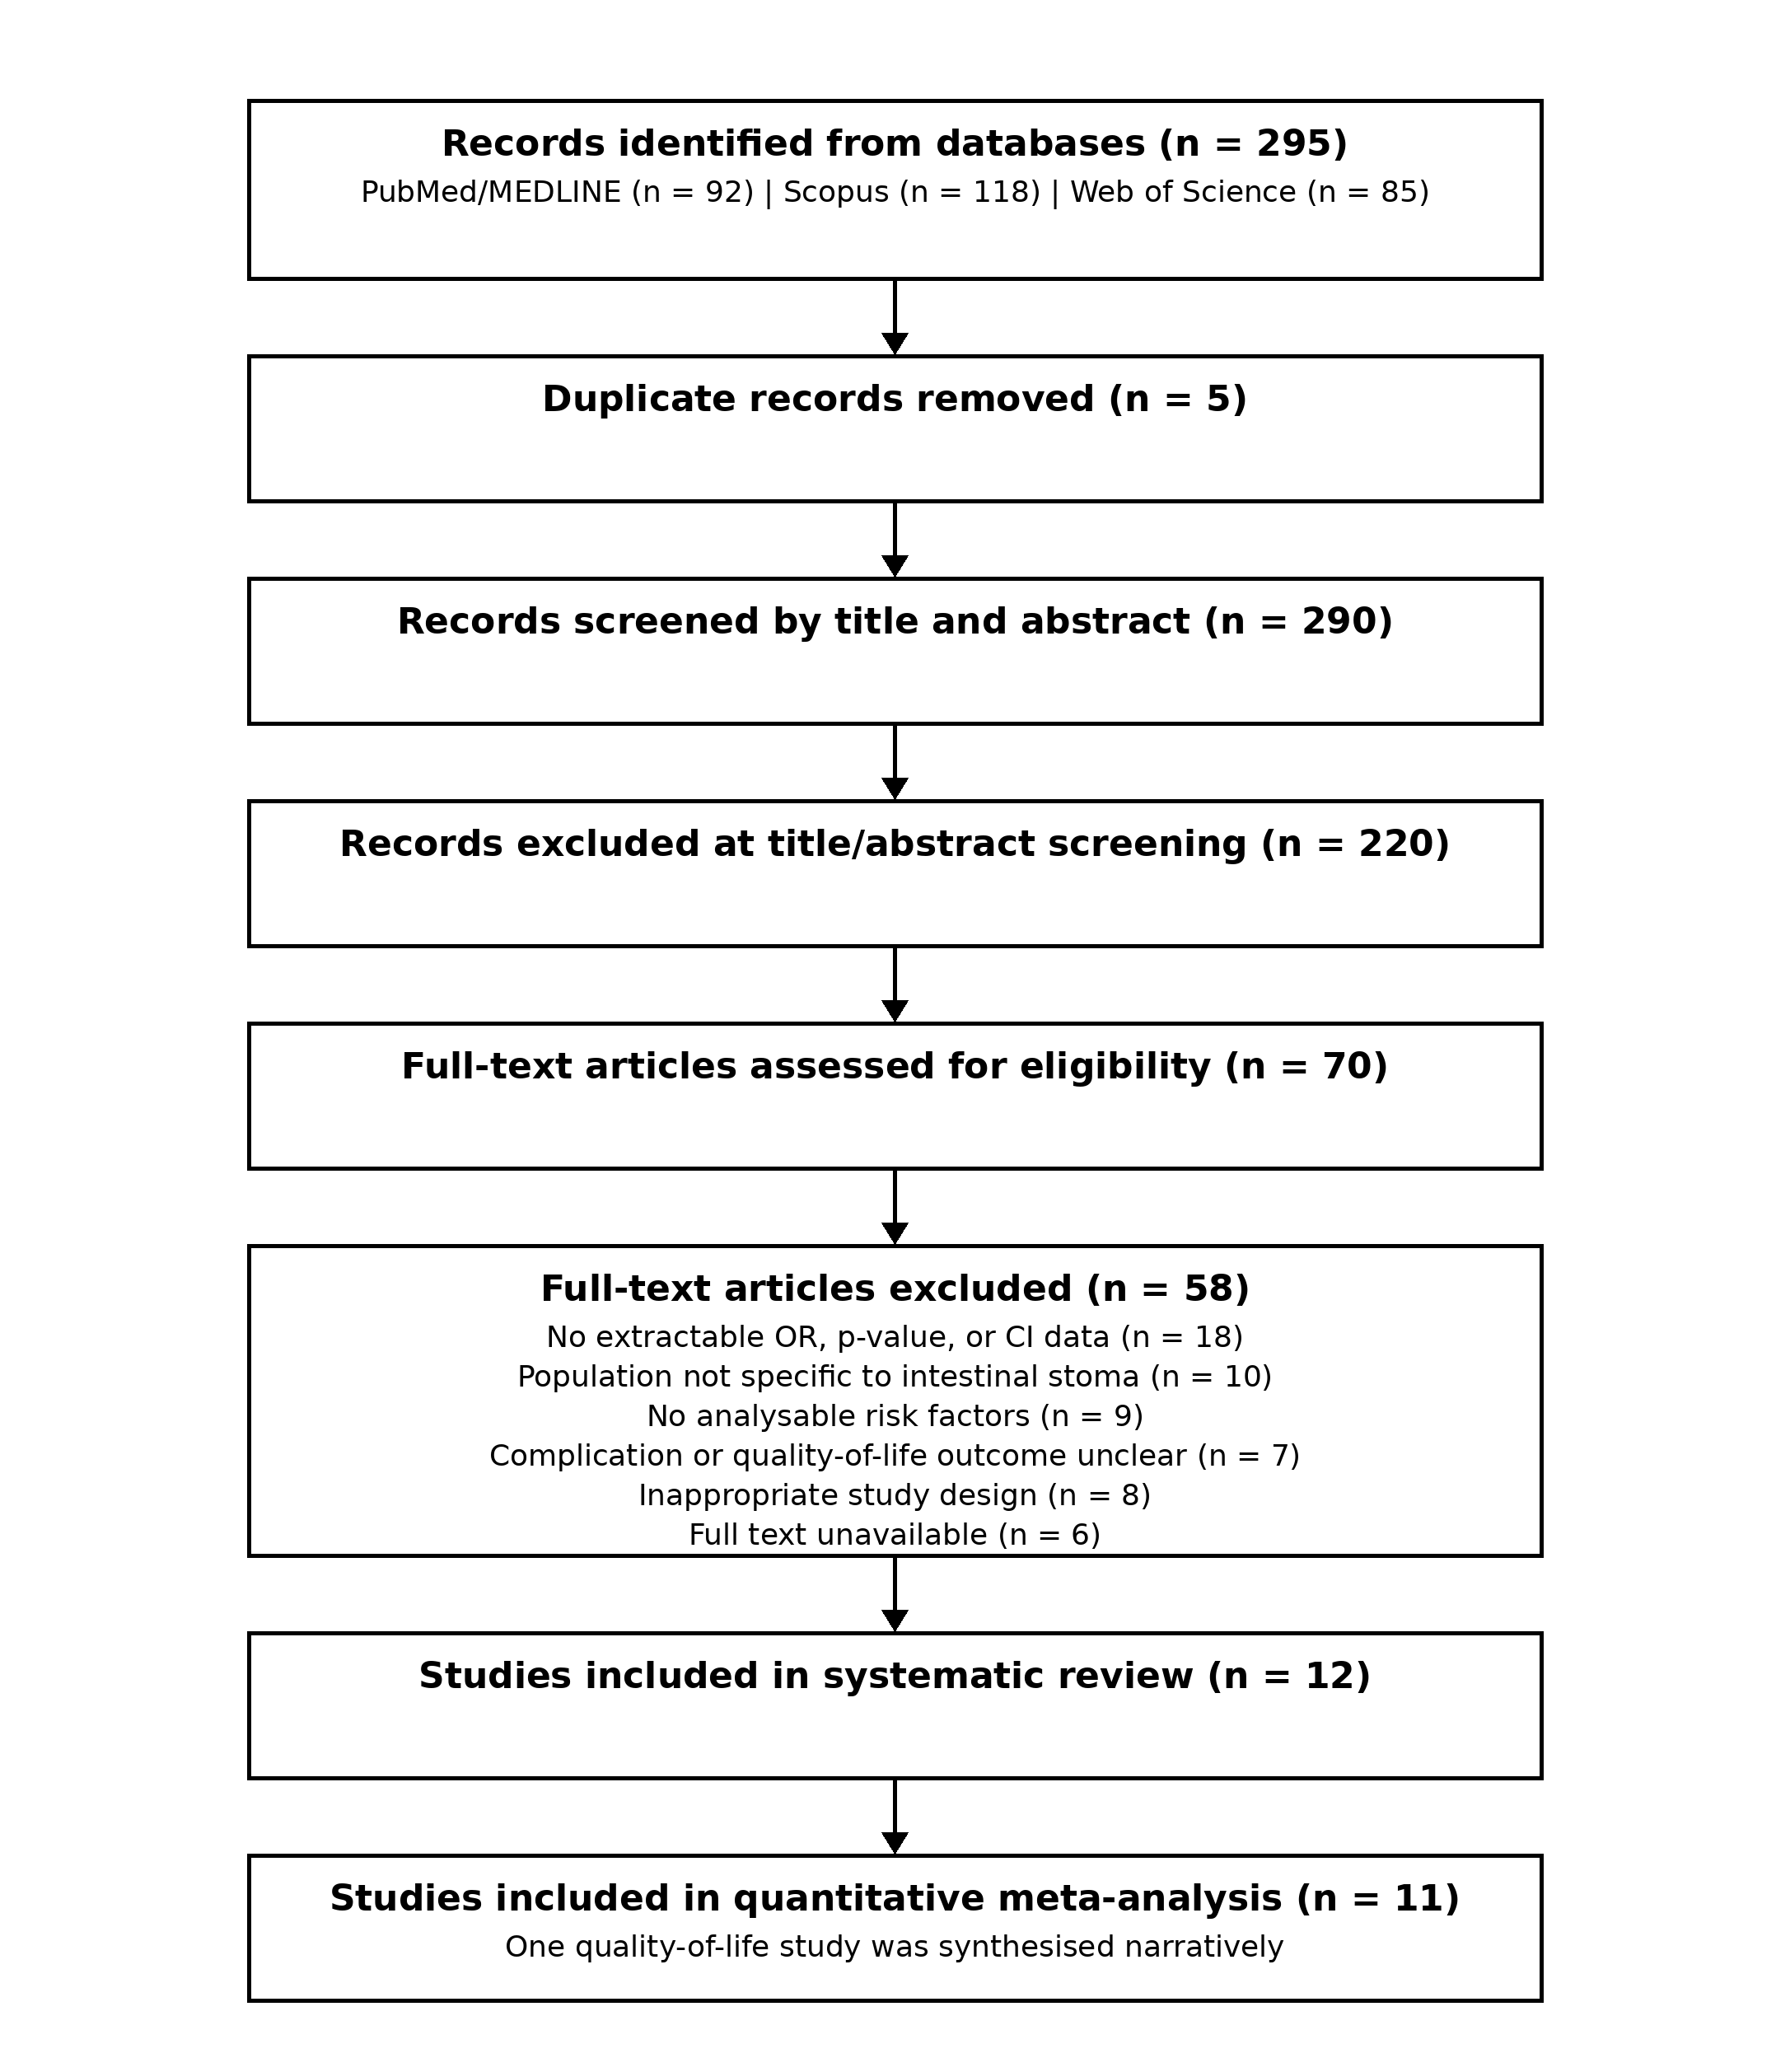
Data extraction and statistical analysis
Data were extracted into Microsoft Excel and included author, year, country, study design, sample size, stoma type, risk factors, complication or quality-of-life outcome, and reported statistical estimates, including odds ratio (OR), p-value, confidence interval (CI), and I² when available. For the exploratory quantitative synthesis, the study-level effects included in the meta-analysis were represented on a common standardised effect scale before pooling. The standardised effect estimates and their corresponding measures of uncertainty were entered into JASP to obtain the pooled standardised effect estimate, confidence interval, study weights, and heterogeneity statistics. Between-study heterogeneity was assessed using Cochran’s Q and I². Possible small-study effects or publication bias were explored visually using a funnel plot. Because the included studies evaluated different clinical phases, risk factors, stoma types, and outcome definitions, the pooled estimate was treated as an exploratory statistical summary and was not interpreted as a pooled odds ratio, risk ratio, or other single universal clinical risk measure. Quantitative findings were therefore interpreted together with the outcome-specific narrative synthesis. A formal risk-of-bias assessment was not performed; therefore, the methodological quality of the included studies was not formally graded.
Results
Study characteristics
Twelve studies were included in the systematic review.^{23–34} Eleven studies contributed to the quantitative meta-analysis, while the cross-sectional quality-of-life study by Liu et al. was summarised narratively. The included studies covered emergency stoma formation, early ostomy complications, comparisons between ileostomy and colostomy, high-output stoma, postoperative ileus and readmission, stoma-related obstruction, morbidity after stoma closure, sigmoid stoma complications after abdominoperineal resection, prediction of early complications, and quality of life among patients with a stoma. Based on the publication years of the 12 included studies, 2021 and 2024 were the most frequent years, with four studies each. Retrospective designs predominated, and early or postoperative stoma complications were the most frequent outcome focus. The distribution of the included studies is summarised in Table 3.
Table 3. Distribution of included studies by characteristics
Characteristic | Category | No. of studies | Percentage
Publication year | 2019 | 2 | 16.67%
Publication year | 2020 | 1 | 8.33%
Publication year | 2021 | 4 | 33.33%
Publication year | 2024 | 4 | 33.33%
Publication year | 2025 | 1 | 8.33%
Study design | Retrospective cohort/study | 9 | 75.00%
Study design | Retrospective descriptive study | 1 | 8.33%
Study design | Prediction model study | 1 | 8.33%
Study design | Cross-sectional study | 1 | 8.33%
Outcome focus | Early/postoperative stoma complications | 5 | 41.67%
Outcome focus | High-output stoma/postoperative ileus/readmission | 2 | 16.67%
Outcome focus | Stoma-related obstruction | 1 | 8.33%
Outcome focus | Complications after stoma closure | 2 | 16.67%
Outcome focus | Sigmoid stoma complications after abdominoperineal resection | 1 | 8.33%
Outcome focus | Quality of life | 1 | 8.33%

The included studies were conducted in England/Scotland, Turkey, Taiwan, South Korea, Japan, Mexico, and China. Their clinical focus varied considerably. Emergency stoma formation and early ostomy complications were examined in the studies by MacDonald et al. and Ayik et al.^{23–25} Yang et al. compared common complications of protective loop ileostomy and colostomy, whereas Lee et al. and Takeda et al. evaluated high-output stoma, postoperative ileus, readmission, and predictive factors.^{26–28} Maemoto et al. focused on stoma-related obstruction; Kilinc et al. and Vergara-Fernández et al. assessed morbidity after stoma closure; Lv et al. examined sigmoid stoma complications; Ba et al. developed a prediction model for early complications; and Liu et al. evaluated quality of life among colorectal cancer patients with a stoma.^{29–34} Detailed characteristics of the 12 included studies are presented in Table 4.
Table 4. Characteristics of the 12 included studies
Study | Country | Design/sample | Focus | Key findings
MacDonald et al. (2024) | England/Scotland | Multicentre retrospective; emergency stoma patients | Postoperative outcomes/risk factors | Relevant to complications after emergency stoma formation and postoperative clinical risk factors.
Ayik et al. (2024) | Turkey | Retrospective cohort; n=872 | Early ostomy complications | At least one complication occurred in 573 patients; patterns differed between emergency and elective surgery.
Ayik et al. (2020) | Turkey | Retrospective descriptive; n=572 | Ostomy complications and nursing care | Early complications occurred in 56.5%; common problems included peristomal irritant contact dermatitis and mucocutaneous separation.
Yang et al. (2024) | Taiwan | Retrospective cohort; n=410 | Ileostomy vs colostomy | Ileostomy was more often associated with high-output stoma, whereas colostomy was more often associated with stoma retraction.
Lee et al. (2021) | South Korea | Retrospective cohort; n=302 | High-output stoma, ileus, readmission | Postoperative ileus was an independent risk factor for all-cause and ileus-related readmission.
Takeda et al. (2019) | Japan | Retrospective comparative; 151 analysed | High-output ileostomy | High-output syndrome occurred in 36 of 151 patients; predictive factors were assessed using logistic regression.
Maemoto et al. (2021) | Japan | Retrospective; n=155 | Stoma-related obstruction | Stoma-related obstruction occurred in 7.7%; ileal-pouch anal anastomosis was an independent risk factor.
Kilinc et al. (2021) | Turkey | Retrospective descriptive; n=179 | Stoma-closure morbidity | ASA score and coronary artery disease were associated with complications; colostomy was reported as a risk factor for postoperative ileus.
Vergara-Fernández et al. (2019) | Mexico | Retrospective; n=136 | Loop ileostomy closure | Reported risk factors included midline laparotomy, immunomodulator use, familial adenomatous polyposis, age ≥65 years, closure <3 months, and parastomal hernia.
Lv et al. (2024) | China | Observational/retrospective | Sigmoid stoma complications | Evaluated risk factors for sigmoid stoma complications after abdominoperineal resection.
Ba et al. (2025) | China | Retrospective prediction-model study | Early stoma complications | Presented risk factors and a prediction model for early postoperative stoma complications in colorectal cancer.
Liu et al. (2021) | China | Cross-sectional; n=359 | Quality of life; narrative synthesis | Quality of life was generally low; temporary stoma, complications, and receiving stoma care from others were associated with lower scores. This study was not included in the pooled meta-analysis.

Exploratory standardised meta-analysis
Eleven studies contributed to the exploratory quantitative meta-analysis displayed in the forest plot. The pooled standardised effect estimate was 1.12 (95% CI 0.60–1.65), with t(10)=4.80 and p<0.001. Between-study heterogeneity was substantial (Q(10)=104.53, p<0.001; I²=86.98%), indicating considerable variation among the included studies. The funnel plot was not fully symmetrical, with more estimates distributed to the right of the centre line and several points associated with larger standard errors. Because the included studies differed in clinical phase, risk factors, stoma type, and outcome definition, the pooled result should be interpreted as an exploratory standardised statistical summary rather than as a single universal clinical measure of risk. Accordingly, the quantitative findings were interpreted together with the outcome-specific narrative synthesis. The quantitative meta-analysis is summarised in Table 5. The forest plot is shown in Figure 2, and the funnel plot is shown in Figure 3.
Table 5. Summary of the exploratory standardised meta-analysis
Parameter | Result
Studies in quantitative meta-analysis | 11
Pooled standardised effect estimate | 1.12 (95% CI 0.60–1.65)
Pooled-effect test | t(10)=4.80, p<0.001
Cochran’s Q | Q(10)=104.53, p<0.001
I² | 86.98%
Funnel-plot observation | Not fully symmetrical
Interpretation | Exploratory standardised statistical summary with substantial heterogeneity; not interpretable as a single universal clinical risk estimate and should be considered together with outcome-specific findings.
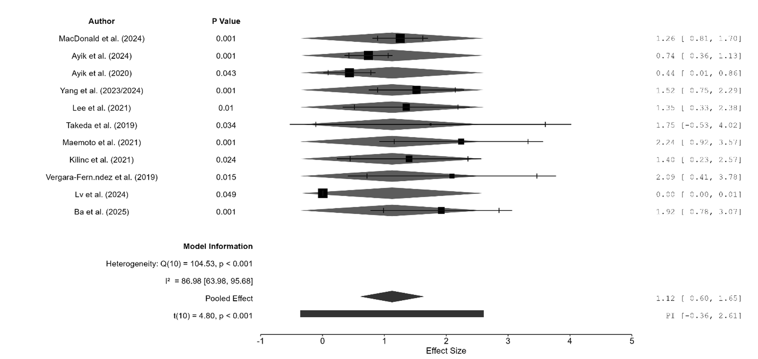
Figure 2. Forest plot of standardised effect estimates in the exploratory meta-analysis of stoma-related outcomes
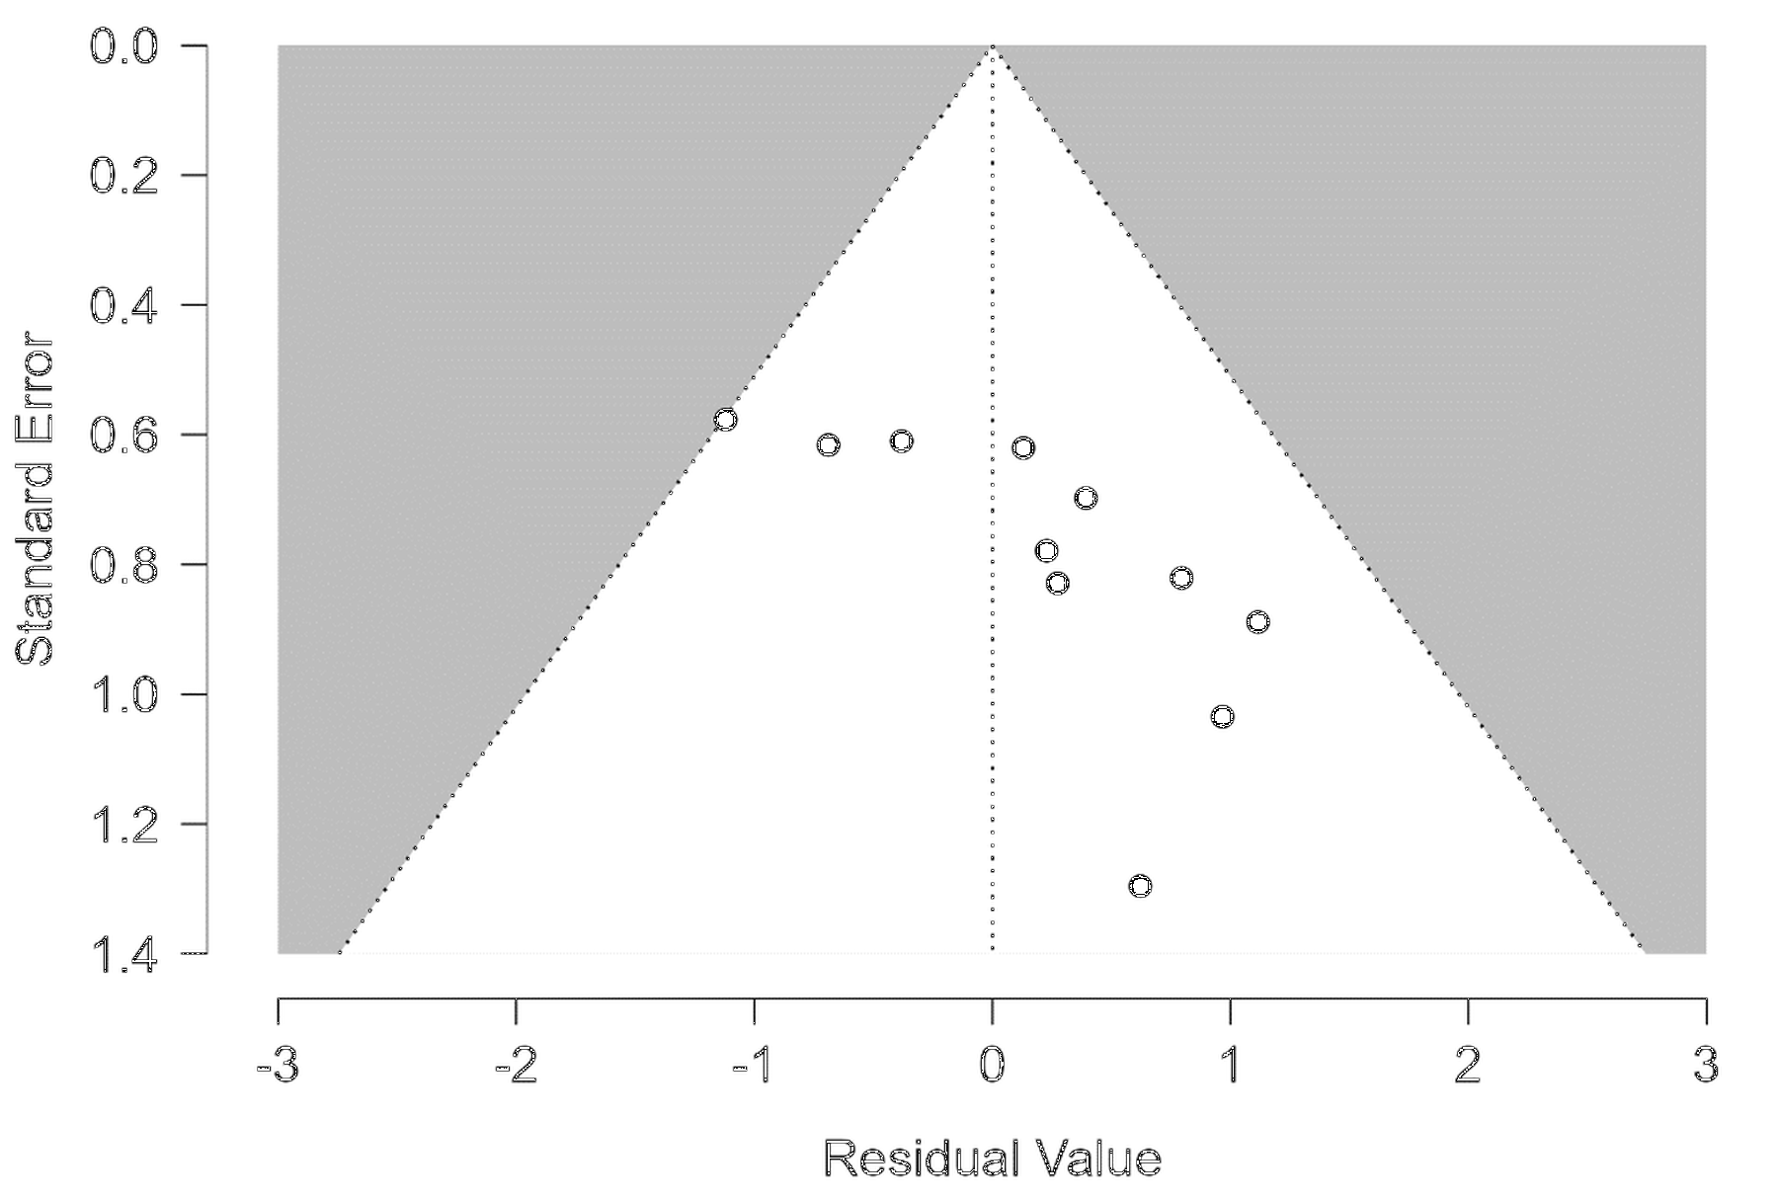
Figure 3. Funnel plot of the exploratory standardised meta-analysis
Discussion
The findings indicate that postoperative complications in patients with intestinal stoma should not be viewed as a single clinical outcome. The included studies addressed different complications and phases of care, ranging from emergency stoma formation and early postoperative morbidity to high-output stoma, obstruction, readmission, stoma closure, and quality of life.^{23–34} The substantial heterogeneity in the pooled analysis is therefore clinically plausible and limits interpretation of the standardised summary effect as a uniform clinical measure of risk. Standardisation allowed study-level effects to be expressed on a common statistical scale, but it did not make the underlying clinical outcomes equivalent.
Risk factors were distributed across patient-related, procedural, anatomical, and stoma-care domains. Malignant disease, comorbidity, loop ostomy, female sex, neoadjuvant therapy, ileostomy, low stoma height, obesity, and emergency surgery were associated with selected complications in the included literature.^{23,24} Broader systematic evidence has likewise identified multiple patient-level and procedural risk factors following stoma formation.³⁶
Ileostomy and colostomy showed different complication profiles. Protective colostomy was more strongly associated with stoma retraction in one included study, whereas ileostomy was linked to high-output stoma, fluid imbalance, postoperative ileus, and readmission in other studies.^{26–28} Evidence comparing preventive loop ileostomy and colostomy similarly suggests that individual complications differ by procedure rather than consistently favouring one stoma type across all outcomes.³⁷
Late and skin-related complications further broaden the clinical spectrum. Parastomal hernia has been associated with worse health-related quality of life, while peristomal Candida infection has been examined as a risk factor for surgical-site infection after stoma closure.^{12,13} In rectal cancer patients, loop stoma, stoma height below 10 mm, chemotherapy, and diabetes mellitus have been associated with peristomal skin disorders or worsening skin conditions.¹¹
Quality of life represents a distinct but related dimension of stoma outcomes. The included cross-sectional study evaluated quality of life among colorectal cancer patients living with a stoma.³⁴ Broader evidence indicates that peristomal skin problems, leakage, discomfort, and difficulties with self-care may extend into psychological, social, and functional limitations.^{38,39} Quality-of-life findings should therefore be interpreted as patient-centred outcomes that interact with postoperative morbidity rather than as direct equivalents of complication-risk estimates.
The exploratory quantitative synthesis yielded a pooled standardised effect estimate across the included studies. However, this estimate should not be interpreted as a single clinical risk ratio because the studies differed substantially in design, stoma type, patient population, clinical phase, risk factor, and outcome definition. The high heterogeneity reflects these genuine clinical and methodological differences despite expression of study-level effects on a common standardised scale. The observed funnel-plot asymmetry should also be interpreted cautiously because funnel-plot patterns may be influenced by clinical heterogeneity as well as by small-study effects.
This review has several limitations. PubMed/MEDLINE, Scopus, and Web of Science were searched, but Embase and the Cochrane Library were not included. Quality-of-life studies were fewer than studies of clinical complications. A formal risk-of-bias assessment was not performed, so the methodological quality of the included studies was not formally graded. Subgroup analysis, sensitivity analysis, and meta-regression were not undertaken because few studies were clinically comparable within individual outcome categories. In addition, the pooled standardised effect represents an exploratory statistical summary across heterogeneous stoma-related outcomes and should not be interpreted as an outcome-specific clinical effect size. The search was also restricted to English and/or Indonesian articles and required full-text availability. These limitations reduce confidence in the pooled estimate and reinforce the need to interpret outcome-specific findings alongside the quantitative summary.
Conclusion
Complications after intestinal stoma formation varied across the postoperative course and included early stoma complications, peristomal skin problems, high-output stoma, stoma-related obstruction, readmission, and morbidity after stoma closure. Twelve studies were included in the systematic review and 11 contributed to the quantitative meta-analysis. The exploratory meta-analysis yielded a pooled standardised effect estimate of 1.12 (95% CI 0.60–1.65; t(10)=4.80, p<0.001), with substantial between-study heterogeneity (I²=86.98%). This pooled estimate represents a standardised statistical summary rather than a single universal clinical measure of risk and should therefore be interpreted alongside the outcome-specific findings. Stoma outcomes differed according to patient characteristics, stoma type, clinical phase, and outcome definition. Prevention should therefore combine preoperative risk assessment, appropriate stoma-site and stoma-type planning, postoperative education, peristomal skin monitoring, and continued follow-up, while quality of life should be considered alongside clinical morbidity.
Acknowledgements
None.
Funding Sources
This research received no specific grant from any funding agency in the public, commercial, or not-for-profit sectors.
Conflict of Interest
The authors declare no potential conflicts of interest.
References
1. Qassim T, Saeed MF, Qassim A, Al-Rawi S, Al-Salmi S, Salman MT, et al. Intestinal stomas-Current practice and challenges: An institutional review. Euroasian J Hepatogastroenterol 2023;13:115-9. doi:10.5005/jp-journals-10018-1404.
2. Elnaim AL, Wong M, Sagap I. Intestinal stomas; basics, complications and controversy: systematic review. Acad Med Surg. Published online December 7, 2024. doi:10.62186/001c.127121.
3. Ambe PC, Kugler CM, Breuing J, Grohmann E, Friedel J, Hess S, et al. The effect of preoperative stoma site marking on risk of stoma-related complications in patients with intestinal ostomy: a systematic review and meta-analysis. Colorectal Dis 2022;24:904-17. doi:10.1111/codi.16118.
4. Nozawa H, Sasaki S, Hayashi C, Kawasaki A, Sasaki K, Murono K, et al. Preoperative stoma site marking reduces postoperative stoma-related complications in emergency surgery: a single center retrospective cohort study. Scand J Surg 2024;113:40-9. doi:10.1177/14574969231186282.
5. Dellafiore F, Caruso R, Bonavina L, Udugampolage NS, Villa G, Russo S, et al. Risk factors and pooled incidence of intestinal stoma complications: systematic review and meta-analysis. Curr Med Res Opin 2022;38:1103-13. doi:10.1080/03007995.2022.2081455.
6. Gan JX, Liu HP, Chen K. Prevalence and pooled risk factors of stoma outlet obstruction after colorectal surgery with diverting ileostomy: a systematic review and meta-analysis. Int J Colorectal Dis 2025;40:119. doi:10.1007/s00384-025-04862-5.
7. Toffaha A, Badr A, Al-Dhaheri M, Aleter A, Latif E, Kurer M, et al. Risk factors for stoma outlet obstruction: systematic review and meta-analysis. Langenbecks Arch Surg 2025;410:317. doi:10.1007/s00423-025-03892-5.
8. Zhou L, Qin Z, Wang L. Risk factors and incidence of non-closure stoma in patients with anterior resection of rectal cancer with temporary stoma: a systematic review and meta-analysis. Eur J Surg Oncol 2023;49:107120. doi:10.1016/j.ejso.2023.107120.
9. Brady RRW, Sheard D, Howard K, Vestergaard M, Boisen EB, Mather R, et al. The prevalence of leakage, peristomal skin complications and impact on quality of life in the first year following stoma surgery. Nurs Rep 2025;15:107. doi:10.3390/nursrep15030107.
10. Poliani A, Marcomini I, Butti P, Nedesca ED, Manara DF, Villa G. Stoma leakage: prevalence, associated factors, and assessment tools-a scoping review. Nurs Rep 2026;16:46. doi:10.3390/nursrep16020046.
11. Shiraishi T, Ogawa H, Katayama C, Osone K, Okada T, Katoh R, et al. Association of chemotherapy and stoma features with peristomal skin disorders in rectal cancer patients. Sci Rep 2025;15:42214. doi:10.1038/s41598-025-26387-1.
12. Glynn J, Hollingworth W, Harris J, Mohiuddin S, Ellis L, Reeves BC, et al. The impact of parastomal hernia on quality of life using data from the CIPHER prospective cohort study. Eur J Health Econ 2025;26:1209-18. doi:10.1007/s10198-025-01768-5.
13. Jose A, Kothari R, Sharma DB, Sharma D. Incidence and impact of peristomal candidiasis on outcomes after intestinal stoma closure: a prospective study. Trop Doct 2025;55:121-3. doi:10.1177/00494755251329636.
14. Zeng Z, Hu Y, Hou S, Yang R, Shi Z, Li X. Risk factors for complications after infantile enterostomy: development of a clinical prediction model. Front Public Health 2025;13:1566789. doi:10.3389/fpubh.2025.1566789.
15. Zewude WC, Derese T, Suga Y, Teklewold B. Quality of life in patients living with stoma. Ethiop J Health Sci 2021;31:993-1000. doi:10.4314/ejhs.v31i5.11.
16. Leite Junior VdO, Vieira GG, Lima KS, Costa SM, Carvalho ARBd, Soeiro VMdS, et al. Quality of life and its determinants in older adults with intestinal stomas: a cross-sectional study. Int J Environ Res Public Health 2025;22:375. doi:10.3390/ijerph22030375.
17. Lupo R, Rubbi I, Barletta A, Mele C, Lezzi A, Botrugno I, et al. Quality of life and psychophysical consequences in individuals with intestinal stoma: an observational study. Int J Environ Res Public Health 2025;22:1327. doi:10.3390/ijerph22091327.
18. Açil HC, Yilmaz AÇ, Aygin D. The effect of recovery status and life conditions on the quality of life in colorectal cancer patients with stoma: a path analysis. Front Psychol 2025;16:1693626. doi:10.3389/fpsyg.2025.1693626.
19. Díaz-Sánchez C, Rodríguez-Muñoz PM, Navarro-López V, Carmona-Torres JM, Sánchez-Gil A, Sánchez-González JL, et al. Impact of ostomy on quality of life in patients with colorectal cancer: a systematic review and meta-analysis. Healthcare (Basel) 2026;14:444. doi:10.3390/healthcare14040444.
20. Sritan S. Factors contributing to the quality of life among Thai patients diagnosed with colorectal cancer with a stoma: an integrative review. J Adv Nurs 2023;79:1-14. doi:10.1111/jan.15460.
21. Page MJ, McKenzie JE, Bossuyt PM, Boutron I, Hoffmann TC, Mulrow CD, et al. The PRISMA 2020 statement: an updated guideline for reporting systematic reviews. BMJ 2021;372:n71. doi:10.1136/bmj.n71.
22. Higgins JPT, Thomas J, Chandler J, Cumpston M, Li T, Page MJ, et al. Cochrane Handbook for Systematic Reviews of Interventions. Version 6.5. Cochrane; 2024. Available from: https://www.cochrane.org/authors/handbooks-and-manuals/handbook/current.
23. MacDonald S, Wong L-S, Ng HJ, Hastings C, Ross I, Quasim T, et al. Post-operative outcomes and identification of risk factors for complications after emergency intestinal stoma surgery: a multi-centre retrospective study. Colorectal Dis 2024;26:994-1003. doi:10.1111/codi.16947.
24. Ayik C, Bişgin T, Cenan D, Manoğlu B, Özden D, Sökmen S. Risk factors for early ostomy complications in emergency and elective colorectal surgery: a single-center retrospective cohort study. Scand J Surg 2024;113:50-9. doi:10.1177/14574969231190291.
25. Ayik C, Özden D, Cenan D. Ostomy complications, risk factors, and applied nursing care: a retrospective, descriptive study. Wound Manag Prev 2020;66:20-30. doi:10.25270/wmp.2020.9.2030.
26. Yang Y-W, Huang S-C, Cheng H-H, Chang S-C, Jiang J-K, Wang H-S, et al. Protective loop ileostomy or colostomy? A risk evaluation of all common complications. Ann Coloproctol 2024;40:580-7. doi:10.3393/ac.2022.00710.0101.
27. Lee N, Lee SY, Kim CH, Kwak HD, Ju JK, Kim HR. The relationship between high-output stomas, postoperative ileus, and readmission after rectal cancer surgery with diverting ileostomy. Ann Coloproctol 2021;37:44-50. doi:10.3393/ac.2020.08.03.
28. Takeda M, Takahashi H, Haraguchi N, Miyoshi N, Hata T, Yamamoto H, et al. Factors predictive of high-output ileostomy: a retrospective single-center comparative study. Surg Today 2019;49:482-7. doi:10.1007/s00595-018-1756-2.
29. Maemoto R, Tsujinaka S, Miyakura Y, Fukuda R, Kakizawa N, Takenami T, et al. Risk factors and management of stoma-related obstruction after laparoscopic colorectal surgery with diverting ileostomy. Asian J Surg 2021;44:1037-42. doi:10.1016/j.asjsur.2021.01.002.
30. Kilinc G, Ustun M, Tuncer K, Sert I. Risk factors for the morbidity and mortality of stoma closure. J Coll Physicians Surg Pak 2021;31:1085-8. doi:10.29271/jcpsp.2021.09.1085.
31. Vergara-Fernández O, Trejo-Avila M, Salgado-Nesme N. Multivariate analysis of risk factors for complications after loop ileostomy closure. Cir Cir 2019;87:337-46. doi:10.24875/CIRU.18000611.
32. Lv Q, Yuan Y, Xiang Z. Analysis of risk factors for the sigmoid stoma complications in patients after abdominoperineal resection surgery: an observational study. Medicine (Baltimore) 2024;103:e38751. doi:10.1097/MD.0000000000038751.
33. Ba M-Q, Zheng W-L, Zhang Y-L, Zhang L-L, Chen J-J, Ma J, et al. Construction of a nomogram prediction model for early postoperative stoma complications of colorectal cancer. World J Gastrointest Surg 2025;17:100547. doi:10.4240/wjgs.v17.i1.100547.
34. Liu H, Zhu X, Yu J, He P, Shen B, Tang X, et al. The quality of life of patients with colorectal cancer and a stoma in China: a quantitative cross-sectional study. Adv Skin Wound Care 2021;34:302-9. doi:10.1097/01.ASW.0000744348.32773.b9.
35. Steinhagen E, Colwell J, Cannon LM. Intestinal stomas-postoperative stoma care and peristomal skin complications. Clin Colon Rectal Surg 2017;30:184-92. doi:10.1055/s-0037-1598159.
36. Chan MS, Moore Z, Patton D, McNamara D, O’Connor T, Avsar P. A systematic review of patient risk factors for complications following stoma formation among adults undergoing colorectal surgery. Int J Colorectal Dis 2023;38:238. doi:10.1007/s00384-023-04523-5.
37. Ge Z, Zhao X, Liu Z, Yang G, Wu Q, Wang X, et al. Complications of preventive loop ileostomy versus colostomy: a meta-analysis, trial sequential analysis, and systematic review. BMC Surg 2023;23:235. doi:10.1186/s12893-023-02129-w.
38. D’Ambrosio F, Pappalardo C, Scardigno A, Maida A, Ricciardi R, Calabrò GE. Peristomal skin complications in ileostomy and colostomy patients: what we need to know from a public health perspective. Int J Environ Res Public Health 2022;20:79. doi:10.3390/ijerph20010079.
39. Guerra E, Denti FC, Di Pasquale C, Caroppo F, Angileri L, Cioni M, et al. Peristomal skin complications: detailed analysis of a web-based survey and predictive risk factors. Healthcare (Basel) 2023;11:1823. doi:10.3390/healthcare11131823.

